Instructions for Preparing an Abstract
Lord Rayleigh¹ and Paul Langevin²
¹University of Cambridge, Address, United Kingdom
²Sorbonne University, Address, France
email_address@corresponding.author

This document describes the format instructions for abstracts for IWPMA 2026. It is our goal to be relatively flexible in the format, yet maintain a reasonable degree of consistency between abstracts and papers in the finished product. This document (abstract template) is available on the workshop web site (https://pub.confit.atlas.jp/en/event/iwpma2026) in Word format. All abstracts must be submitted through the web site by July 10, 2026.

General Format Requirements
The general format requirements are as follows:
- Abstract Length: 1 page, 3,000 letters maximum (A4 size paper)
- Margins: 25 mm top and bottom; 25 mm (or 1 inch) on sides
- Title: 14 pt bold Times New Roman (or Times), centered
- Authors/Affiliation/E-mails: The author name(s) in normal type, followed by an affiliation line in italics, and a third line with e-mail address(es) in italics; the authors/affiliation/e-mails may be repeated as necessary for multiple affiliations.
- Text: Text in 11 pt Times New Roman (or Times), 11 pt spacing, justified on both margins
- Figures: insert in text where appropriate, with 11 pt Times New Roman (or Times) caption centered below the figure beginning “Figure 1.”, as shown in the example below
- Tables: as with Figures, but with caption beginning “Table 1.”
- Equations: centered, with equation number at the right
- Units: SI units are preferred
- References: References should appear at the end of the paper as shown below.
Additionally, authors are responsible for obtaining permission for reprinting any material included in their papers that is already copyrighted elsewhere.
An example of an equation is shown below. Figure 1 and Table 1 are figure and table examples.
$$\begin{aligned}ma=F \#\left(1\right)\end{aligned}$$

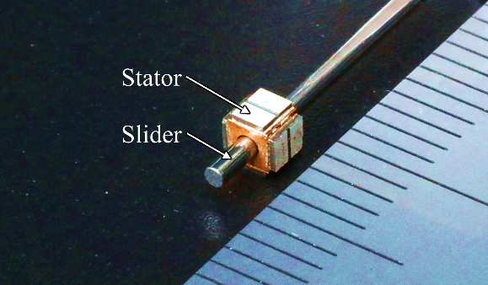
Figure 1 Caption
Table 1 Caption
Diameter [μm] | 500 | 200 | 100
Force factor [mN/V] | 0.28 | 0.12 | 0.072
Max. torque [nNm] | 400 | 80 | 27
Driving frequency [kHz] | 740 | 1800 | 3600
Amplitude [nm/V] | 5 | 5 | 4

Reference
- T. Maeda, T. Hemsel and T. Morita: Jpn. J. Appl. Phys., Vol. 50 (2011) 07HC01

