**Sponsorship for 17th Japan Bioanalysis Forum symposium**

The Japan Bioanalysis Forum (JBF) symposium provides opportunities for discussions on bioanalysis and related topics in Japan once (or twice) a year. Each year nearly 300 people from pharmas, CROs, analytical instruments manufacturers and regulatory authorities gather and conduct lively discussions. The outcomes of these discussions are then posted in related scientific journals, and many parties involved have responded. The 17th JBF Symposium will be held from March 4th to 6th, 2026, at the Arcrea HIMEJI (Himeji Culture and Convention Center) in Himeji-city, Hyogo. The following contents are planned:

・Invited Lecture

・JBF Discussion Group, Poster Presentation

・Poster Presentation

・Basic Course

・Luncheon Seminar

・Banquet

For more details, please visit JBF website (https://pub.confit.atlas.jp/en/event/jbfsympo17). The symposium program will be updated in a timely manner.

An application form for sponsorship is attached on the next page. JBF would like to get your feedback with application for the booths and the advertisements at our 17th symposium. Your sponsorship is greatly appreciated. If you have any questions, please contact us:

Towa Pharmaceutical Co., Ltd. Hitoshi Uchiyama (h-uchiyama@towayakuhin.co.jp)

Daiichi Sankyo Co., Ltd. Makoto Takahashi (makoto.takahashi@daiichisankyo.com)

Mitsubishi Tanabe Pharma Corporation Hiroyuki Shimizu (shimizu.hiroyuki@mb.mt-pharma.co.jp)

Chugai Pharmaceutical Co., Ltd. Takashi Miyayama(miyayamatks@chugai-pharm.co.jp)

Nippon Shinyaku Co., Ltd. Tomohiro Nishimoto(t.nishimoto@po.nippon-shinyaku.co.jp)

Best wishes for your continued successes in the future.

Yours Faithfully,

Japan Bioanalysis Forum

The 17th Symposium Executive Committee

**Application for Sponsorship at 17th JBF symposium**

Your feedback by 10th Oct. is highly appreciated.

Please answer the following questions, and submit to the following addresses.

E-mail address (send to all):

Towa Pharmaceutical Co., Ltd., Hitoshi Uchiyama ([h-uchiyama@towayakuhin.co.jp](mailto:h-uchiyama@towayakuhin.co.jp))

Daiichi Sankyo Co., Ltd., Makoto Takahashi ([makoto.takahashi@daiichisankyo.com](mailto:makoto.takahashi@daiichisankyo.com))

Mitsubishi Tanabe Pharma Corporation, Hiroyuki Shimizu ([shimizu.hiroyuki@mb.mt-pharma.co.jp](mailto:shimizu.hiroyuki@mb.mt-pharma.co.jp))

Chugai Pharmaceutical Co., Ltd., Takashi Miyayama([miyayamatks@chugai-pharm.co.jp](mailto:miyayamatks@chugai-pharm.co.jp))

Nippon Shinyaku Co., Ltd., Tomohiro Nishimoto([t.nishimoto@po.nippon-shinyaku.co.jp](mailto:t.nishimoto@po.nippon-shinyaku.co.jp))

|  |  |
| --- | --- |
| Company name |  |
| Person in charge |  |
| Address |  |
| Phone number |  |
| e-mail |  |

**1. Luncheon Seminar** (165,000 or 297,000 JPY)

At this symposium, we can provide max ten Luncheon Seminar venues. The number of seats is available when arranged in theater style layout (scheduled). Time is 60 minutes of lunch time (scheduled).

Co-sponsorship fees include the following.

(1) Venue fee

(2) Venue facilities fee (desks, chairs, stage, audio equipment, lighting, screen and other equipment, etc.)

(3) Waiting room fees

(4) Abstract of luncheon seminar (If you wish)

The following expenses are not included in the co-sponsorship fees.

(1) Honorarium and traveling expenses for the moderator/chairperson/lecturer (according to your company’s rule)

(2) Food and drinks for the guests, and other equipment in the waiting room

(3) Lunch and drinks (boxed lunch, tea, etc.) for the participants

Please note that the costs of lunch and drinks are separate

The cost hasn't been decided yet. We will let you know once it's been decided.

**Please write the plan /date of your choice.**

Example : □ Plan ( A ), Date: March 4th

1st choice : □ Plan ( ), Date:

2nd choice : □ Plan ( ), Date:

|  |  |  |
| --- | --- | --- |
| Date | March 5th and 6th, 2026 4 or 5 Luncheon Seminars/day | |
| Plan | Plan A | Plan B |
| Number of seats*1 | 40 ~ 80 seats | 20 ~ 40 seats |
| Co-sponsorship fees | 297,000 JPY | 165,000 JPY |

*1：Number of seats available when arranged in theater style layout (scheduled)

**2. Booth** (209,000 JPY/partition and 6,600 JPY/stamp rally activity cost)

The number of exhibition places is limited. At this symposium, we can provide a place (including a desk: W180 cm × D120 cm) for about 30 companies (30 sections). The exhibition hall is the same venue as the poster session. Booth exhibition fee is 215,600 JPY (including special gift fee 6,600 JPY for stamp rally activity). If you hope 2 sections, you may be assigned. Please circle the choice below that you prefer.

|  |  |  |
| --- | --- | --- |
| Applicant for exhibition  (1 section / 209,000 JPY)  Stamp rally activity cost  (6,600 JPY) | Applicant for exhibition  (2 sections / 418,000 JPY)  Stamp rally activity cost  (6,600 JPY) | No plan |
|  |  |  |

**3. Advertisement** (66,000 JPY or 110,000 JPY)

The advertisement on the abstract booklet (only electronic) can be posted. The abstract booklet is A4-size and double pages: one page can accommodate the advertisements of two companies and the other is for an abstract of the presentation. Colored A5-size advertisement will be provided for each company. In addition, an option menu is that you can display a PowerPoint slide advertisement (1 page) between the oral sessions in the main venue. Please circle the choice below that you prefer.

|  |  |  |
| --- | --- | --- |
| Applicant for advertisement without the option menu  (66,000 JPY) | Applicant for advertisement with the option menu  (110,000 JPY) | No plan |
|  |  |  |

**4. Cancellation Policy**

No refunds, except in case of "Force Majeure" (i.e. pandemic situation, etc.)

As a general rule, we cannot accept cancellations once you have completed your application.

Thank you very much for your cooperation.

**5. Supporting member**

JBF call for members for companies and organizations that support and agree with the purpose of our activities.

One of the benefits is a 20% discount on sponsorship fees at JBF symposiums.

If you wish to become a member of JBF, please check the following site.

https://bioanalysisforum.jp/en/join/recruitment.html

**Venue: Arcrea HIMEJI, Hyogo, Japan (https://www.himeji-ccc.jp/en/#access)**

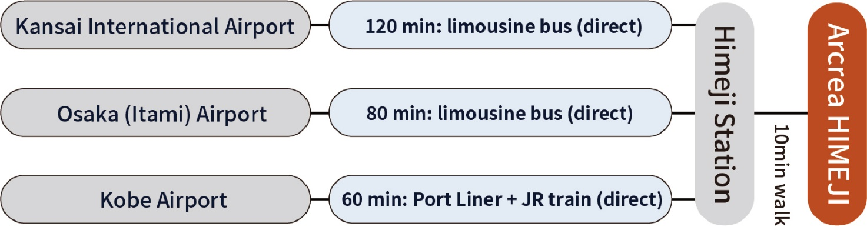

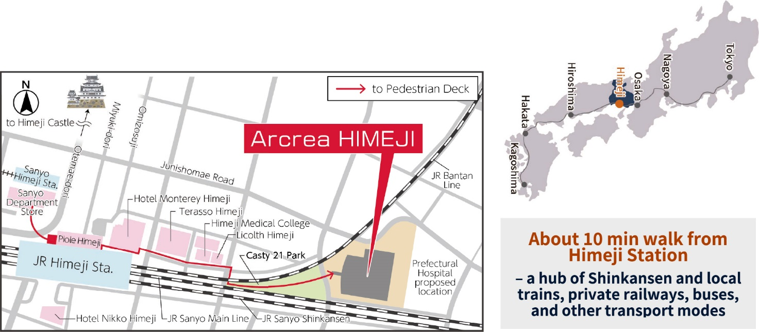

**1F Floor Plan**

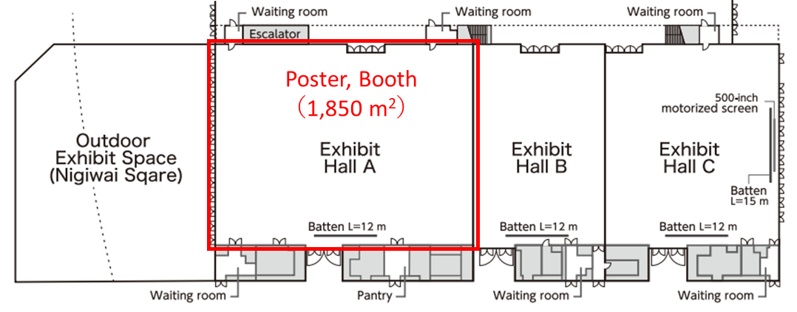

Pamphlet

<https://www.himeji-ccc.jp/img/pdf/pamphlet_A4-en-202304p.pdf>