Sponsorship for 18th Japan Bioanalysis Forum symposium

The Japan Bioanalysis Forum (JBF) symposium provides opportunities for discussions on bioanalysis and related topics in Japan once (or twice) a year. Each year nearly 450 people from pharmas, CROs, analytical instruments manufacturers and regulatory authorities gather and conduct lively discussions. The outcomes of these discussions are then posted in related scientific journals, and many parties involved have responded. The 18th JBF Symposium will be held from March 16th to 18th, 2027, at the SONIC CITY in Omiya-ku,Saitama-shi,Saitama. The following contents are planned:

・Invited Lecture
・JBF Discussion Group, Poster Presentation
・Poster Presentation
・Open Communication
・Luncheon Seminar, Tea Time Seminar
・Banquet

For more details, please visit JBF website (https://pub.confit.atlas.jp/en/event/jbfsympo18). The symposium program will be updated in a timely manner.

An application form for sponsorship is attached on the next page. JBF would like to get your feedback with application for the booths and the advertisements at our 18th symposium. Your sponsorship is greatly appreciated. If you have any questions, please contact us:

Towa Pharmaceutical Co., Ltd. Hitoshi Uchiyama (h-uchiyama@towayakuhin.co.jp)
Daiichi Sankyo Co., Ltd. Makoto Takahashi (makoto.takahashi@daiichisankyo.com)
Sekisui Medical Co., Ltd. Takeshi Okuzono (takeshi.okuzono@sekisui.com)
Chugai Pharmaceutical Co., Ltd. Takashi Miyayama (miyayamatks@chugai-pharm.co.jp)
Nippon Shinyaku Co., Ltd. Tomohiro Nishimoto (t.nishimoto@po.nippon-shinyaku.co.jp)
Astellas Pharma Inc. Masanori Nagata (masanori.nagata@astellas.com)

Best wishes for your continued successes in the future.

Yours Faithfully,
Japan Bioanalysis Forum
The 18th Symposium Executive Committee
Application for Sponsorship at 18th JBF symposium

Your feedback by 2nd Oct. is highly appreciated.

Please answer the following questions, and submit to the following addresses.

E-mail address (send to all):
Towa Pharmaceutical Co., Ltd., Hitoshi Uchiyama (h-uchiyama@towayakuhin.co.jp)
Daiichi Sankyo Co., Ltd., Makoto Takahashi (makoto.takahashi@daiichisankyo.com)
Sekisui Medical Co., Ltd., Takeshi Okuzono (takeshi.okuzono@sekisui.com)
Chugai Pharmaceutical Co., Ltd., Takashi Miyayama(miyayamatks@chugai-pharm.co.jp)
Nippon Shinyaku Co., Ltd., Tomohiro Nishimoto(t.nishimoto@po.nippon-shinyaku.co.jp)
Astellas Pharma Inc., Masanori Nagata (masanori.nagata@astellas.com)

Company name
Person in charge
Address
Phone number
e-mail

1. Luncheon Seminar (700,000* or 604,000* JPY)
At this symposium, we can provide six Luncheon Seminar venues. The number of seats is available when arranged in theater style layout (scheduled). Time is 60 minutes of lunch time (scheduled).

Co-sponsorship fees include the following.
(1) Venue fee
(2) Lunch boxes and drinks for the participants fee*
(3) Venue facilities fee (desks, chairs, stage, audio equipment, lighting, screen and other equipment, etc.)
(4) Waiting room fees
(5) Abstract of luncheon seminar (If you wish)
* : The Lunch boxes and drinks fee is scheduled to be revised. We will let you know once it's been decided.

The following expenses are not included in the co-sponsorship fees.
(1) Honorarium and traveling expenses for the moderator/chairperson/lecturer (according to your company’s rule)
(2) Food and drinks for the guests, and other equipment in the waiting room

Please write the plan /date of your choice.
Example : ■ Plan ( A ), Date: March 16th
1st choice : □ Plan ( ), Date:
2nd choice : □ Plan ( ), Date:

Date | March 17th and 18th, 2027 3 Luncheon Seminars/day
Plan | Plan A | Plan B
Number of seats | 100 seats | 80 seats
Co-sponsorship fees | 700,000 JPY^{*1} | 604,000 JPY^{*1}
*1：The Lunch box and drink fee is scheduled to be revised. We will let you know once it's been decided.

2. Teatime Seminar (306,000* JPY)
At this symposium, we can provide four teatime Seminar venues. The number of seats is available when arranged in theater style layout (scheduled). Time is 30 minutes of afternoon (scheduled).

Co-sponsorship fees include the following.
(1) Venue fee
(2) Sweets and drinks for the participants fee
(3) Venue facilities fee (desks, chairs, stage, audio equipment, lighting, screen and other equipment, etc.)
(4) Waiting room fees
(5) Abstract of Teatime seminar (If you wish)

The following expenses are not included in the co-sponsorship fees.
(1) Honorarium and traveling expenses for the moderator/chairperson/lecturer (according to your company’s rule)
(2) Sweets and drinks for the guests, and other equipment in the waiting room

Please write the date of your choice.
Example : ■ Date: March 16th
1st choice : □ Date:
2nd choice : □ Date:

Date | March 16th and 17th, 2027 2 Teatime Seminars/day
Number of seats | 80 seats
Co-sponsorship fees | 306,000 JPY^{*1}

3. Booth (247,500 JPY or 489,500 JPY)
The number of exhibition places is limited. At this symposium, we can provide a place (including a desk: W180 cm × D90 cm) for about 40 companies (40 sections). The exhibition hall is the same venue as the poster session or rest room. Booth exhibition fee is 247,500 JPY. If you hope 2 sections, you may be assigned. Please circle the choice below that you prefer. A stamp rally activity will be held during the symposium. JBF will provide the special gifts, backing cards and stamps for stamp rally activity.

Applicant for exhibition  (1 section / 247,500 JPY) | Applicant for exhibition  (2 sections / 489,500 JPY) | No plan

3. Advertisement (55,000 JPY or 110,000 JPY)
The advertisement on the program booklet (only electronic) can be posted. The program booklet is A4-size. Colored A5-size advertisement will be provided for each company. In addition, an option menu is that you can display a PowerPoint slide advertisement (1 page) between the oral sessions in the main venue. Please circle the choice below that you prefer.
The abstract booklet includes all accepted abstracts presented at the 2027 JBF symposium. The abstract booklet will be provided separately from the program booklet.

Applicant for advertisement without the option menu  (55,000 JPY) | Applicant for advertisement with the option menu  (110,000 JPY) | No plan
4. Cancellation Policy
No refunds, except in case of "Force Majeure" (i.e. pandemic situation, etc.)
As a general rule, we cannot accept cancellations once you have completed your application.

Thank you very much for your cooperation.

5. Supporting member
JBF call for members for companies and organizations that support and agree with the purpose of our activities.
One of the benefits is a 20% discount on sponsorship fees at JBF symposiums.
If you wish to become a member of JBF, please check the following site.
https://bioanalysisforum.jp/en/join/recruitment.html

Venue
Sonic City, Saitama, Japan (https://www.sonic-city.or.jp/en.html )

Palace Hotel OMIYA , Saitama, Japan (https://www.palace-omiya.co.jp/english/access.html )

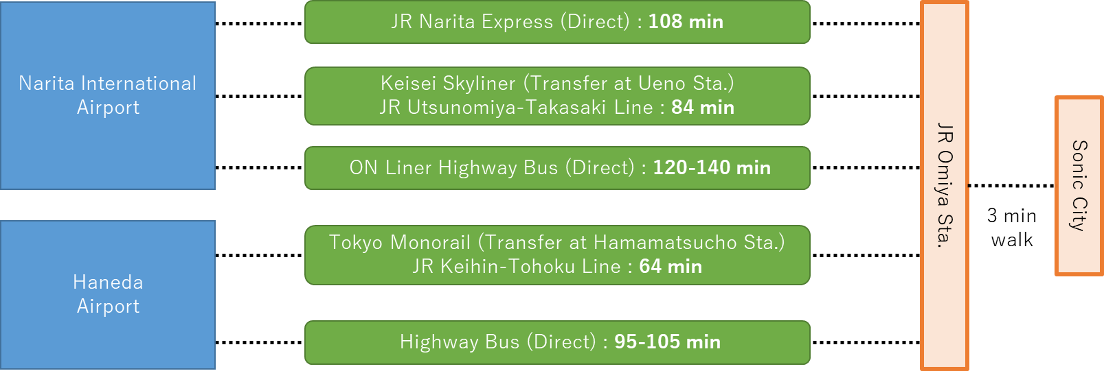

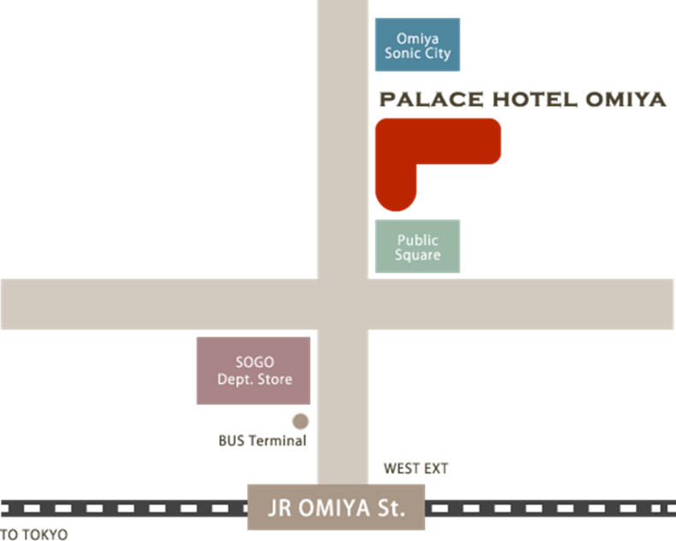

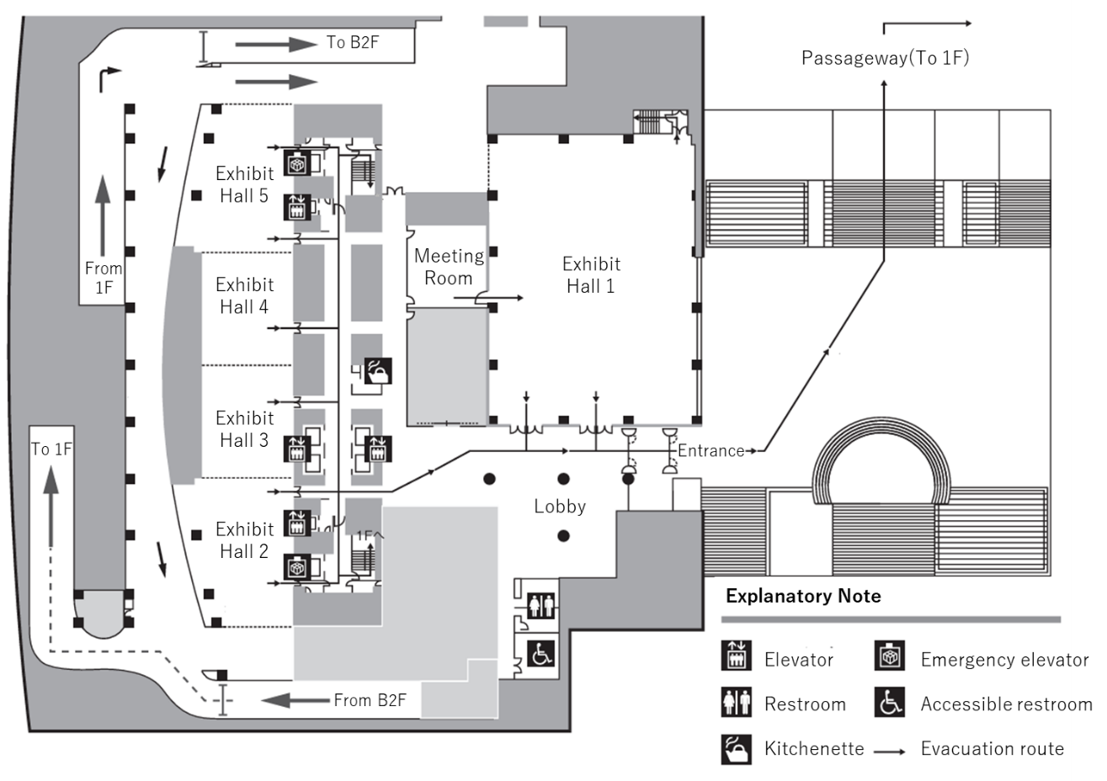

Exhibit Hall 1 : Poster Presentation, DG Poster Presentation and Sponsor Booth
Exhibit Hall 3 : Rest Space and Sponsor Booth (in reserve)
Meeting Room : Poster Presentation and DG Poster Presentation
Exhibit Hall 2 : Oral Presentation (Satellite Venue)，Luncheon Seminar and Teatime Seminar
Exhibit Hall 4 and 5 : Oral Presentation (Secondary Venue)，Luncheon Seminar and Teatime Seminar

