Format for Summary of JSSI & JSSE Joint Conference on Snow and Ice Research
- Sub Title Here -

○Taro Seppyo ¹, Koujiro Yuki ², and Hanako Ooyuki ³

1. Introduction
This document is the abstract format for JSSI and JSSE Joint Conference. This abstract will appear as it is in PDF based abstract.

2. How to prepare
2.1 Contents
In the abstract, please describe the purpose, methods and results of your research clearly and straightforward. Insufficient description may not be accepted for presentation. Since this is an academic journal, please pay attention to the expression of the title, text, charts, and photographs so as not to be regarded as an advertising act of a company.

2.2 Format
The abstract should be prepared on one page of A4 size paper. Please download and use the template (this document, MS-Word format) from the conference website. This conference offers two types of formats: two-column and one-column formats. Please use your preferred format. Also, for each form, the copyright notices of the Japan Society of Snow and Ice Science and the Japan Society of Snow Engineering are available, so please use the template of the academic society to which you want to transfer the copyright.

2.3 Style
Please do not change the margin width and header of this template. Do not remove the line at the bottom of abstract, the conference information at the header, and the copyright notice at the bottom. Since 2023, no Japanese information (title, authors, and affiliation) are required.

2.4 Title
The title should be written on the first line using a 12-point Arial font. If you need a subtitle, write it on the second line. The font size for subtitles should be 10.5 points. Line spacing is 14 points.

2.5 Authors
The author's name should be written in the center of the 3rd line using a 10.5-point Time New Roman font. In case of joint names, please put a circle in front of the speaker's name. Also, put a number such as 1, 2 on the right shoulder of each for affiliation. Please keep one line between the author's name and the text. Line spacing is 14 points.

2.6 Headline and text
Use 9 point font. The main headline is "1. Introduction", and the subheading should be "1.1 Subheading". Use Arial fonts for major and subheadings, and Time New Roman fonts for the text. Line spacing should be 13 points.

2.7 Figure, Table, and Photographs
Figures and tables are called Figures 1, 2 and Tables 1, 2, etc., in the order in which they appear. Photographs are treated as figures. Figures are explained below, and tables are explained above. Please use your own original figures, photographs, and tables.

2.8 References
When writing a list of references, number them in order of citation and describe them at the end of the text. Please describe in the order of authors (year): article title, journal, volume(issue), start page – end page. Journal in Italic, and volume in bold.

3. Abstract Submission
Please convert the abstract into a PDF file, and then submit it from the "Submit presentation" on the conference website.

References
1) Woods, T. and Hewitt, I.J. (2023): A model of the weathering crust and microbial activity on an ice-sheet surface. Cryosphere, 17, 1967-7987.
2) Pedley, M., Paren, J.G., and Potter J.R. (1988): Localized basal freezing within George VI Ice Shelf, Antarctica. J. Glaciol., 34, 71–77.

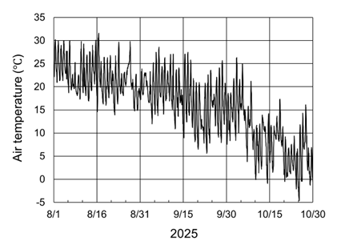
Fig. 1 Hourly temperature at Kitami from 1st August to 30th October of 2025

