**Please use about 14 pt. font for the title,**

**Times or Times New Roman fonts are recommended.**

Please keep

25mm margin.

Please keep

25mm margin.

Author Name 1 and Author Name 2 (12 pt.)

1 Department of Chemical Engineering, Seikei University1 (12 pt.)

2 Department of Polymer Engineering, Kakou University

This template sheet provides how to write the manuscript for the preprints of the Seikei-Kakou annual/autumnal meeting. A4 paper size and two pages are recommended as the manuscript. All authors should read through the instructions carefully written in below not to make a simple mistake. The organizing committee strongly requests the authors to submit the manuscript before the deadline as PDF file (maximum size: 5MB). 200 words for abstract.

*Keywords*: Please write 3 - 5 keywords.

**Introduction**

Recent years, polymer processing --------------------

------ (Extended abstract should be clearly printed for photocopying publication. Main text is single space with 9 or 10 pt., Times or Times New Roman fonts, and the length is two pages.) --------------------

## Experimental Setup

-------------------------------------------------------------

--------------------------------------------------------------

## Numerical Simulation

-------------------------------------------------------------

---------------------------------------------------------------

 (1)

---------------------------------------------------------------

**Results and Discussion**

Authot Name 1* and Author Name 2

*Department of Chemical Engineering, Kakou Univ.

5-8-5, Oosaki, Shinagawa-ku, Tokyo 141-0032

Tel: 03-5436-3822, Fax: 03-3779-9698

E-mail: seikei_tarou@kakou.ac.jp

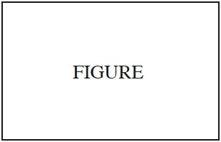

Figure 1 Sample figure

Table 1 Sample table

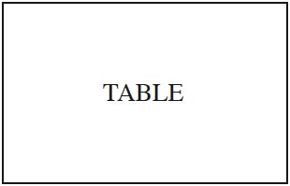

**Conclusions**

-------------------------------------------------------------

---------------------------------------------------------------

---------------------------------------------------------------

---------------------------------------------------------------

**References**

1) Tarou Seikei, Jiro Kakou and Sukio Kanagata: *Polymer Processing*, **1**, 10 (2019)

2) Tarou Seikei, Jirou Kakou and Sukio Kanagata: *Polymer Engineering and Science*, **31**, 20 (2010)

Please keep 25mm margin for printed area.

Extended abstract must be two pages.